***K8 Homework***

**Minikube installation and verification:**

curl -LO https://storage.googleapis.com/minikube/releases/latest/minikube-linux-amd64

sudo install minikube-linux-amd64 /usr/local/bin/minikube && rm minikube-linux-amd64

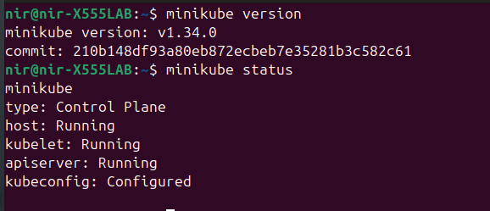

**Create Namespaces**

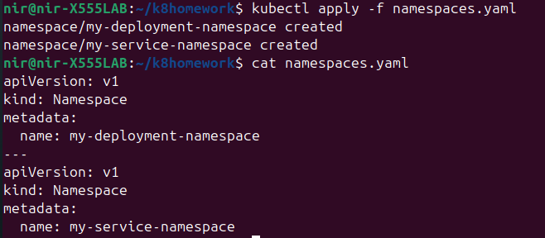

**Define the Deployment:**

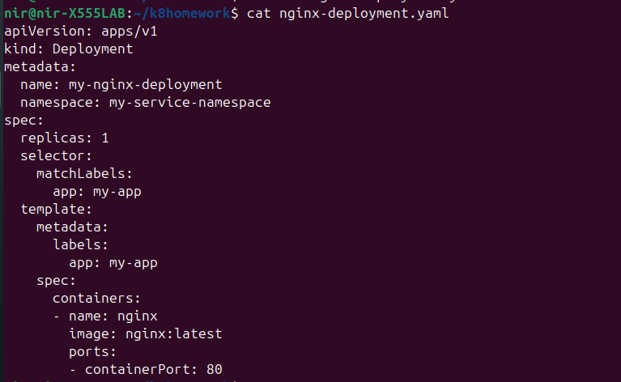

### **Create & Verify the Deployment:**

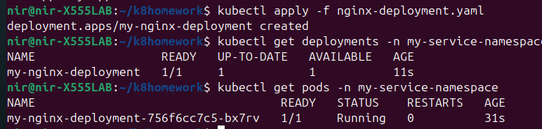

**Define the Service**

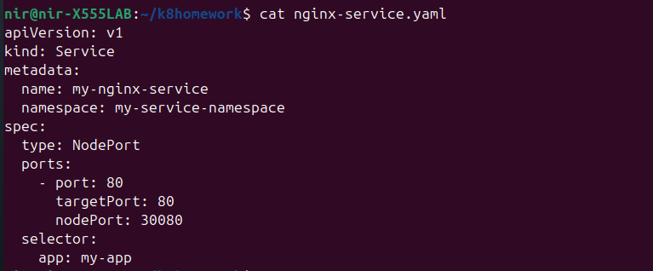

**Create the Service**



**Verify the Service**

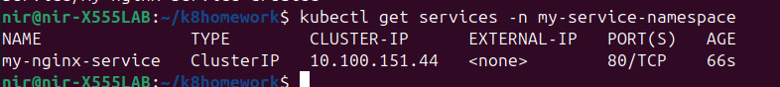

Run curl with the cluster IP to get the nginx web interface.

